FIRST YR B.TECH COMPUTER WORKSHOP LAB MANUAL RECORD, RCOEM

# Name:

**Branch & Year: CSE, First Yr. Section: G**

# Practical 1

**Aim:** Design a static web page using HTML which displays personal information which includes following:

1. Creating headings and paragraphs, Insert a line break in web page content.
2. Format the text by using formatting tags (Font & Color)
3. Create a navigation bar and provide link to a web page and Insert ordered and unordered list.

# Code:

<!DOCTYPE html>

<html>

<body>

<h1>This is heading 1</h1>

<h2>This is heading 2</h2>

<h3>This is heading 3</h3>

<h4>This is heading 4</h4>

<h5>This is heading 5</h5>

<h6>This is heading 6</h6>

</body>

</html>

# Screenshot Output:

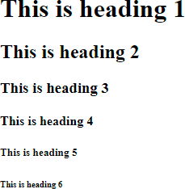

**Conclusion:**